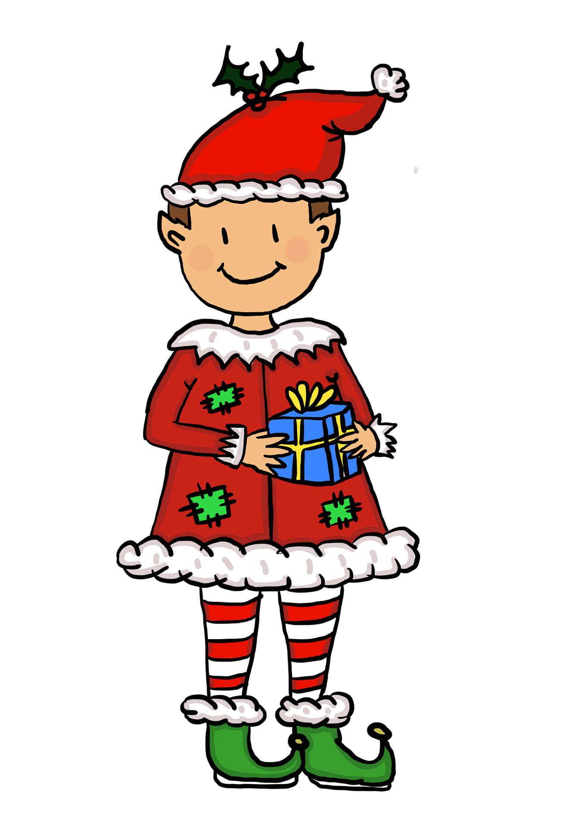**Help the little elf find the Christmas objects around the house. Write ✔️ when you find it.**

|  |  |  |  |
| --- | --- | --- | --- |
| **Christmas Objects** |  | **Christmas Objects** |  |
| **gingerbread house** |  | **Christmas lights** |  |
| **stocking** |  | **yellow gift** |  |
| **Christmas tree** |  | **blue gift** |  |
| **purple gift** |  | **candy cane** |  |
| **bells** |  | **powdered sugar** |  |

