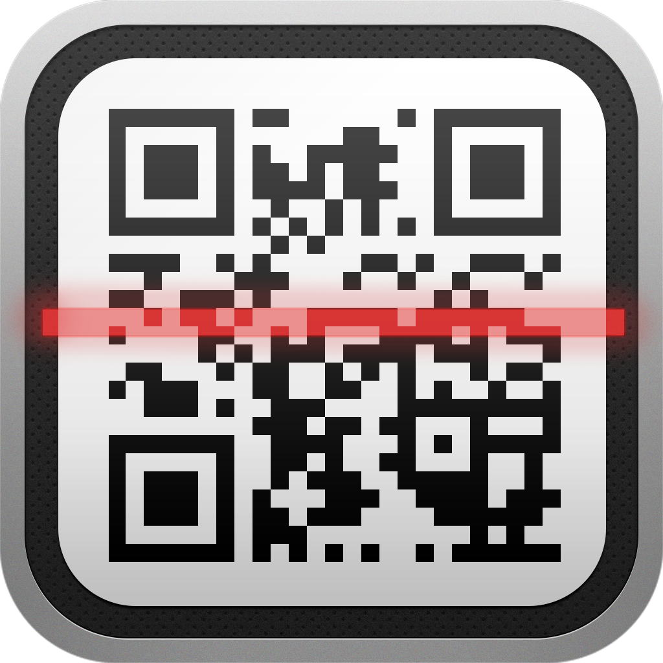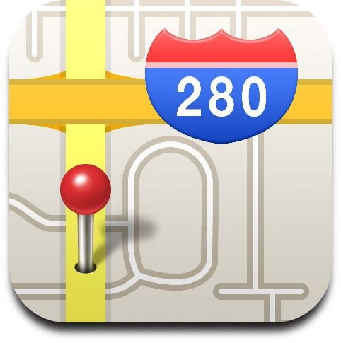

Denise St-Pierre, Service local du RÉCIT, CSBE 

Translated by : Dianne Stankiewicz, ESL Consultant, CSBE

Name : __________________________



|  |  |  |
| --- | --- | --- |
|  | Challenge 8:   Scan the following QR code using the application "QR Code Reader" or the application "iNigma".  Who do you see?  _______________________________ | /4 |
|  | Challenge 9:   Find the price of the application "Virtual Human Body".   Answer:   ________________________________ | /4 |
|  | Challenge 10:  Write your mailing address In the application "Maps" and take a screenshot of the result. | With help  /5 |
|  | **TOTAL POINTS** |  |

iPad Rally

The purpose of this rally is to appropriate (or to simply remember) a few basic iPad functions that we will use during our day. You have 30 minutes to complete as many challenges as possible with the use of the applications installed on your device or by using the Internet.

Each correct answer gives a certain number of points related to the difficulty of the challenge. A higher score is awarded if you do not need help of the document “Rallye iPad – Quelques démarches et astuces (Aide)”

Ready? Let’s go!RALLY



3

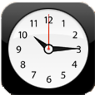

**iPad Rally**

The purpose of this rally is to appropriate (or to simply remember) a few basic iPad functions that we will use during our day. You have 30 minutes to complete as many challenges as possible with the use of the applications installed on your device or by using the Internet.

Each correct answer gives a certain number of points related to the difficulty of the challenge. A higher score is awarded if you do not need help of the document “Rallye iPad – Quelques démarches et astuces (Aide)”

Ready? Let’s go!

|  |  |  |
| --- | --- | --- |
|  | Challenge 4:  Type the following text in the "Notes" application, respecting punctuation, capitalization, etc.  **It's time to go back to school. I’m very happy to see colleagues and especially to discover new educational uses of the iPad!** | /5 |
|  | Challenge 5:  Vacations. Search the web for a photo of either a place you visited or an activity you did during your summer vacation and save it in "Photos".  Verify that the photo is in fact in your photo library and assign yourself the points you earned. | Without help  /5  With help  /3 |
|  | Challenge 6:   Using the application "Camera”, take a selfie to represent how you feel today.   (☺ , ☹, 😐 ) | /3 |
|  | Challenge 7:   Email the 2 images in your photo library to a person of your choice. | /5 |

|  |  |  |
| --- | --- | --- |
|  | Challenge 1:   Use the "Clock" application to time the 30 minutes you have to complete this rally. Select the ringtone "By The Seaside" to signal the end of the activity.   Assign yourself the points **when you hear the ringtone at the end of 30 minutes.** | Without help  /5  With help  /3 |
|  | Challenge 2:   Configure the iPad so you can send and receive email.  Before you assign yourself points, complete challenge 3. | Without help  /10  With help  /8 |
|  | Challenge 3:   Write a blank email to **Enter your email** here. When he/she receives it, assign yourself points (This proves that you were able to properly configure your email on the iPad.) |

1

2