Annexe:
Activity 3 – Mix and Match – Stores
 | 
 | 
 | 
 | 
 | 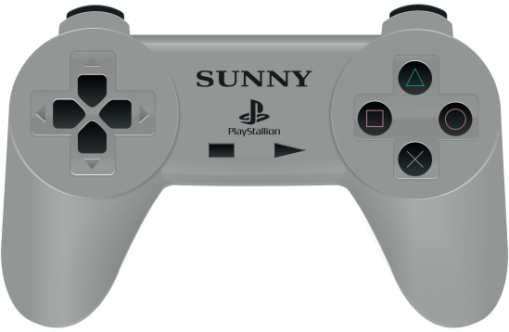
 | 
 | 
 | 

Supermarket | Video game shop
Drugstore | Office supply store
Convenience store | Sport shop
Gas station | Clothing store
Post office | Library
Restaurant | Butcher’s
Bank | Bakery
Petshop | Hardware store

Activity 3 – Mix and Match – Objects
 | Croissants | Candies
Pizza   | Stamps | Windshield washer
Check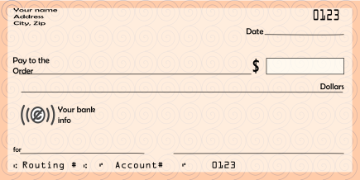 | Aquarium | Pipes  
Video Game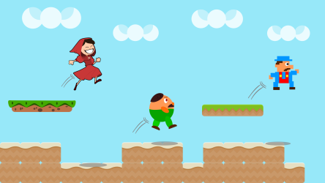 | Highlighters | Skates

Dress   |   Book | Steak
Envelopes   | Cough syrup | Muffins
Screws | Milk   | Pain killers
Collection coins | Helmet | Fries  


Activity 4 – Getting Around
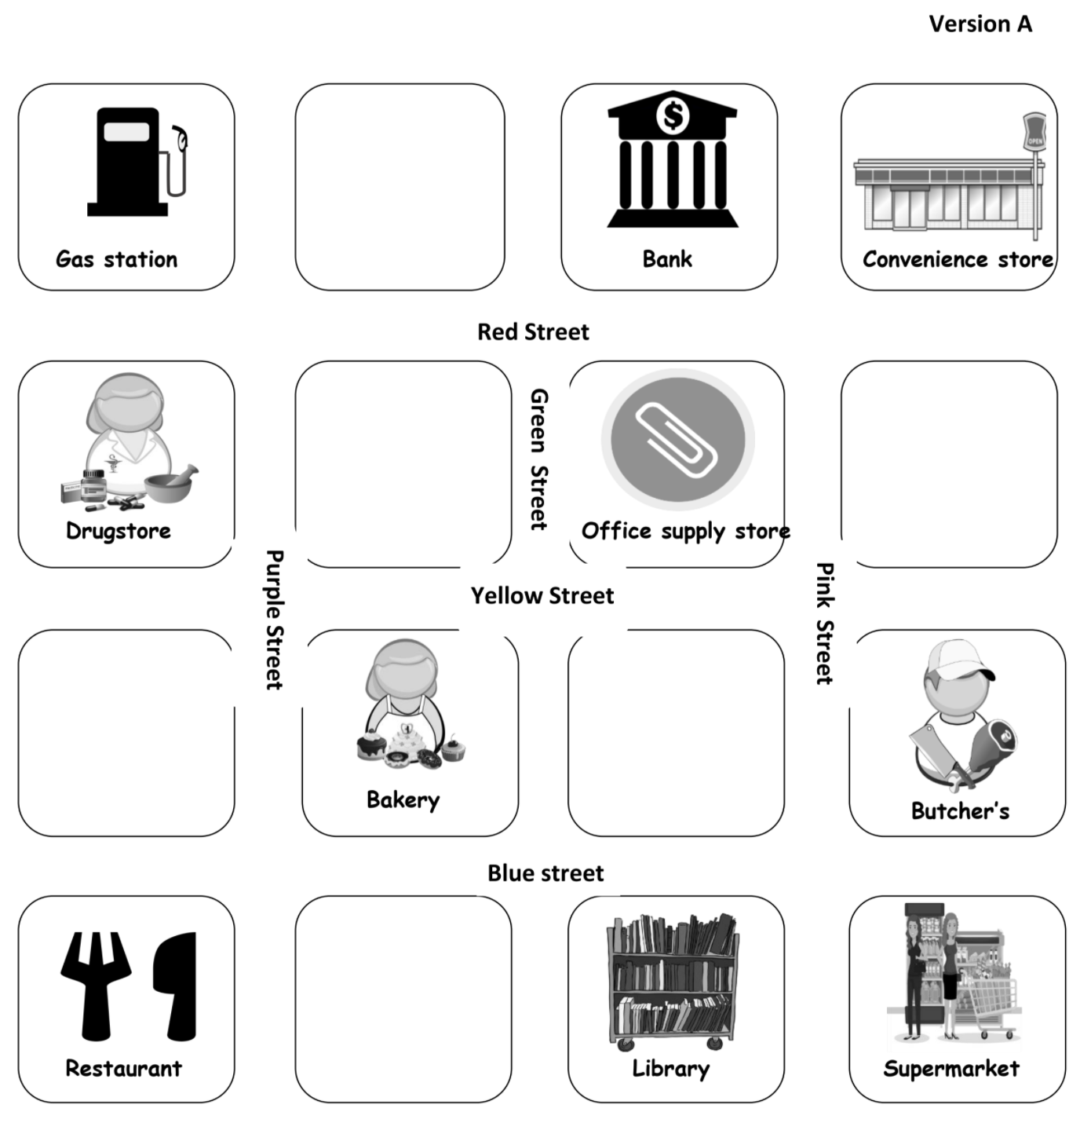
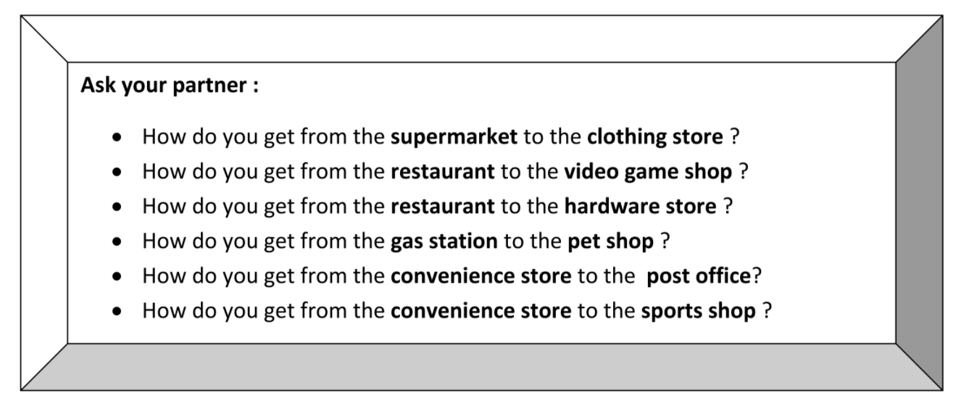

Activity 4 – Getting Around
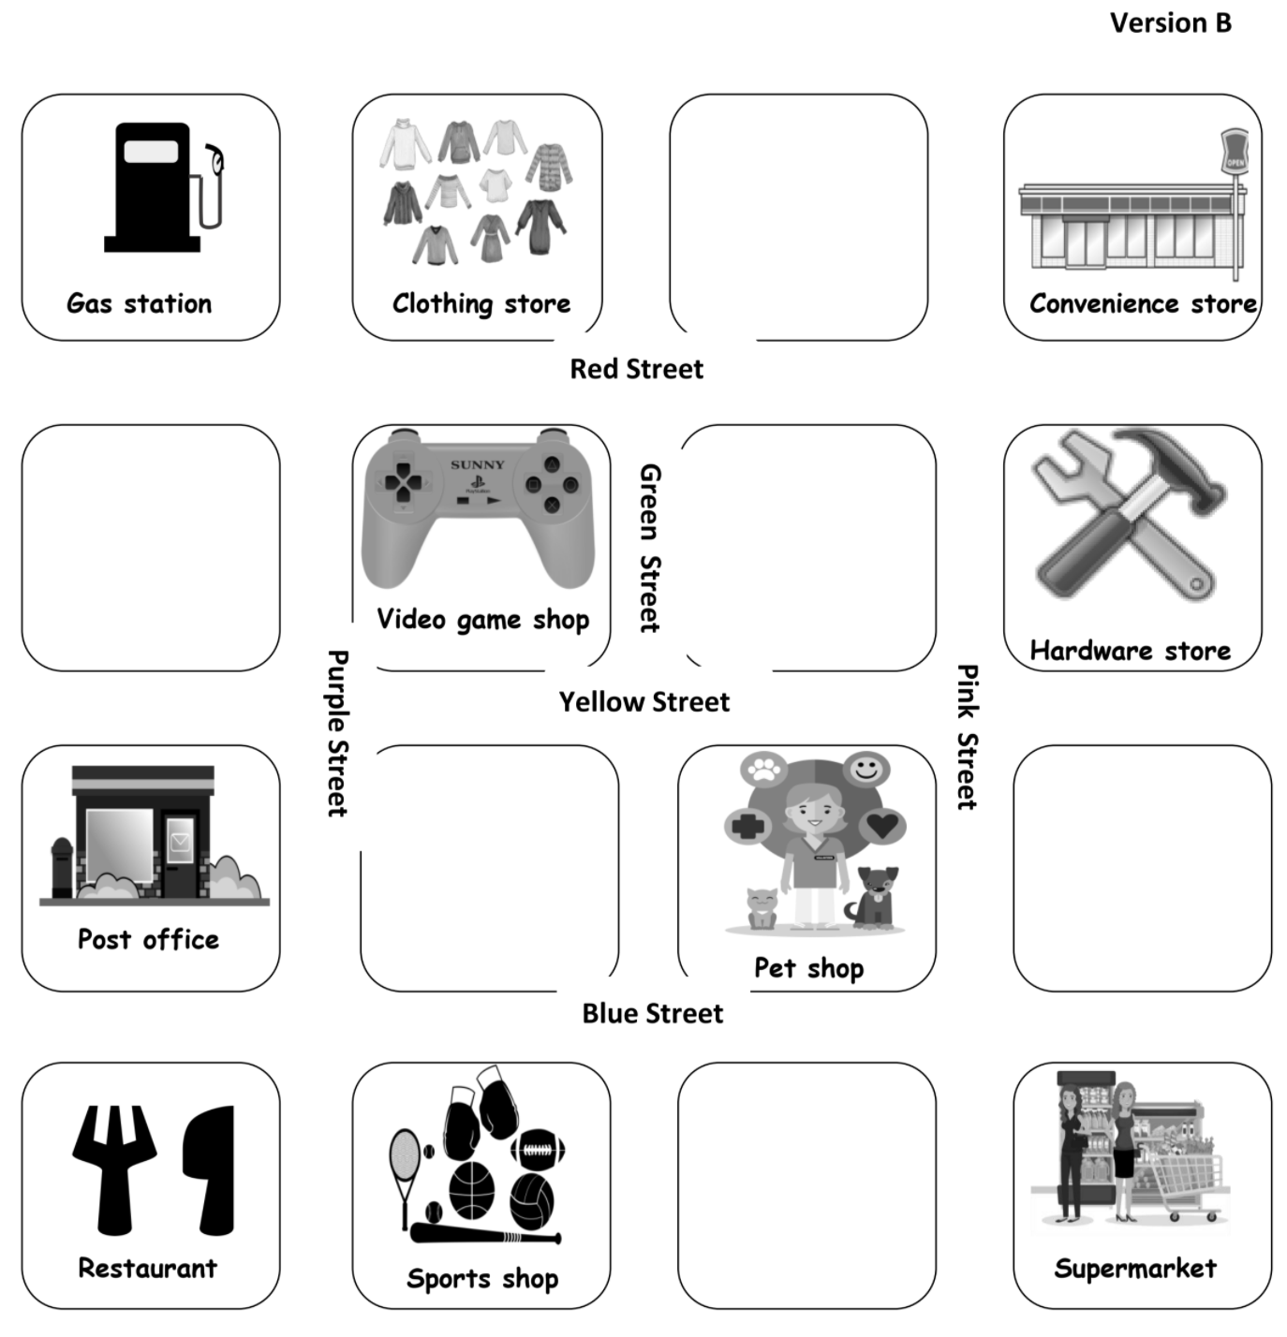
Ask your partner :
How do you get from the grocery store to the drugstore ?
How do you get from the grocery store to bank ?
How do you get from the restaurant to the office supply store ?
How do you get from the gas station to the library ?
How do you get from the gas station to the butcher’s?
How do you get from the convenience store to the bakery ?

Activity 6 – Let’s Practice (EMPTY MAP)
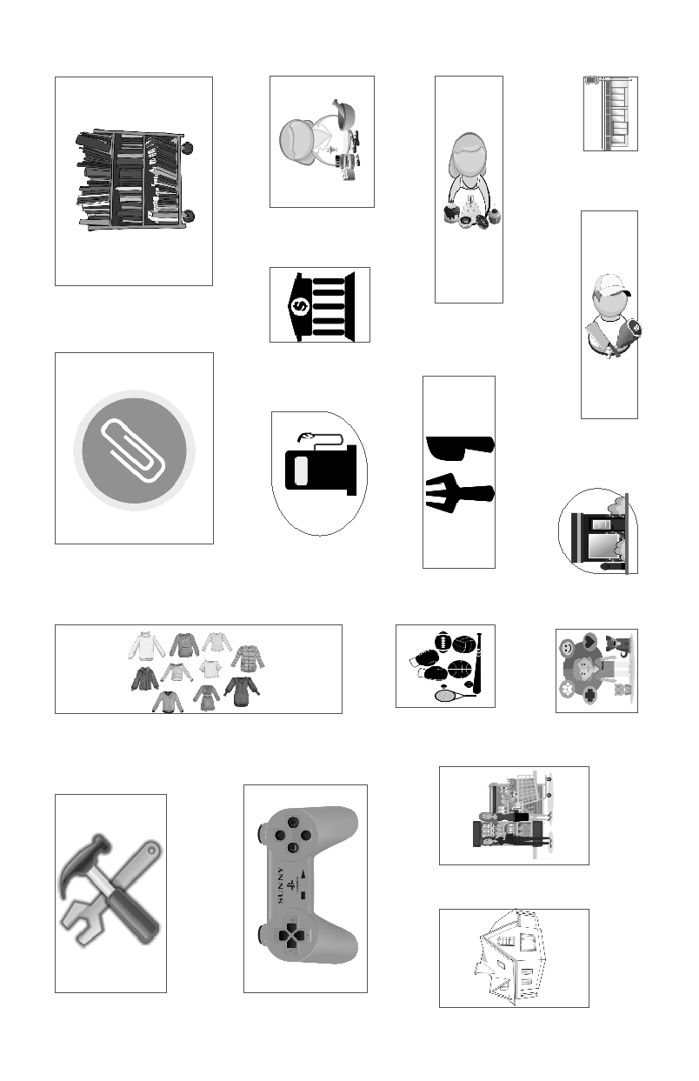

Activity 6 – Let’s Practice, Part 1
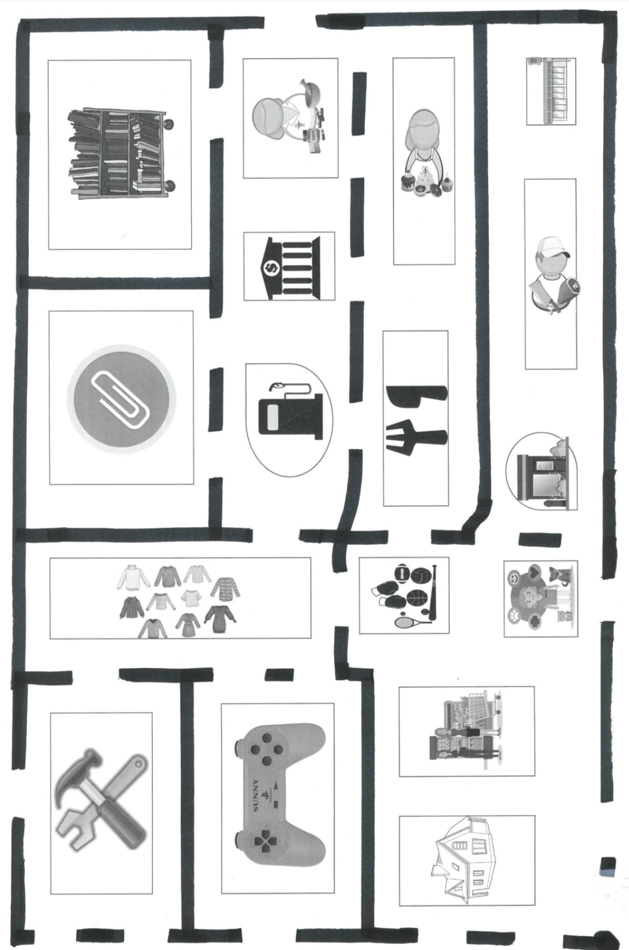

Activity 6 – Let’s Practice, Part 1, ANSWER KEY
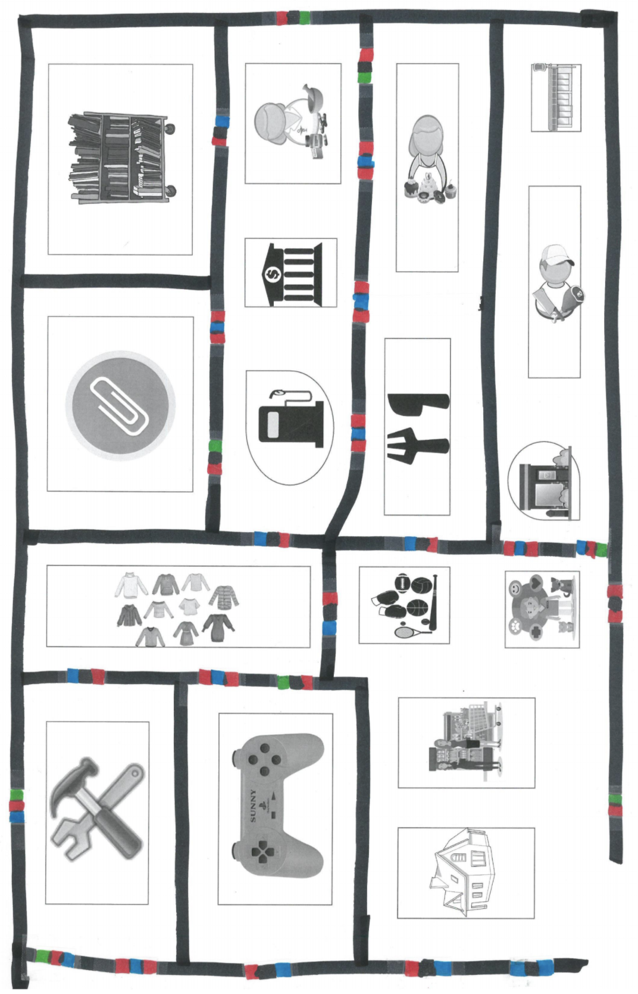
Activity 6 – Let’s Practice, Part 2
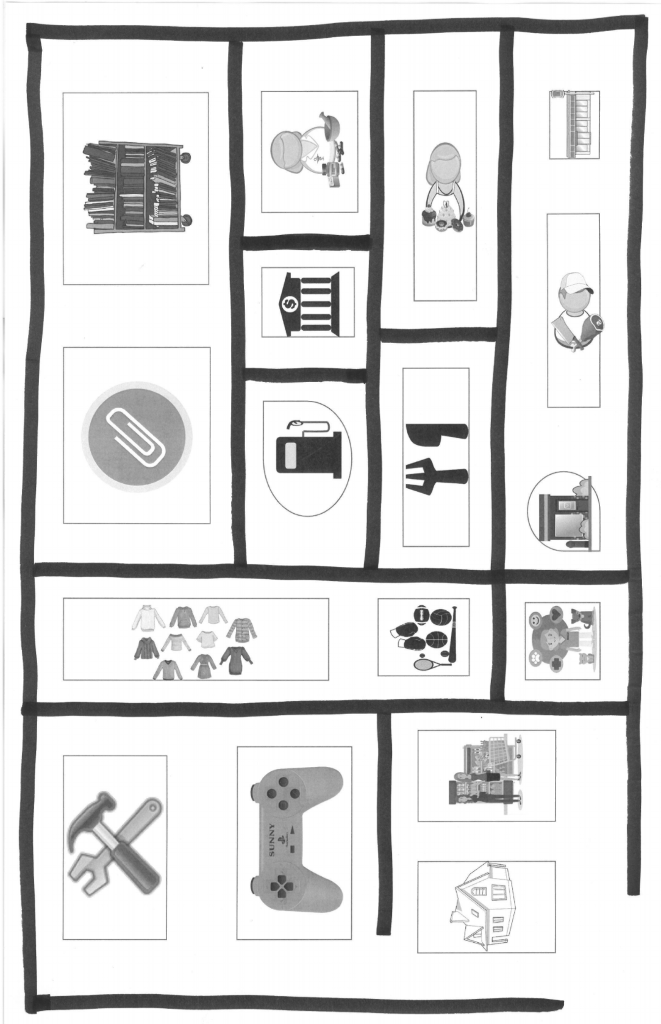
Activity 6 – Let’s Practice, Part 2, ANSWER KEY
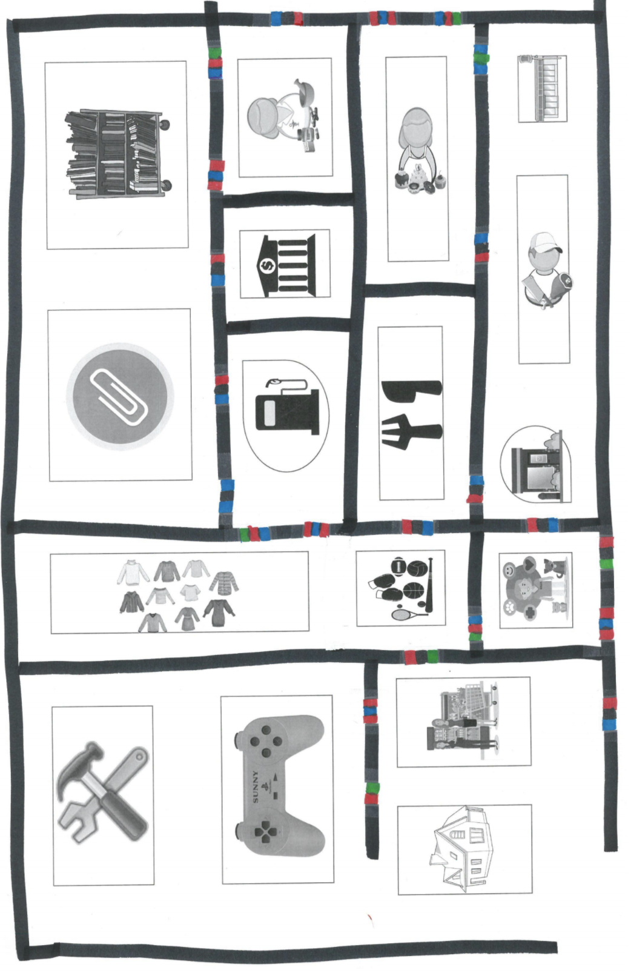
Activity 3 – C1 Evaluation grid
ELEMENTARY CYCLE THREE ESL GENERIC EVALUATION TOOL
(MEES, 2017)
COMPETENCY 1, TO INTERACT ORALLY IN ENGLISH
 | Participation in exchanges | 20 |  | - Speaks throughout  - Contributes substantial content (Explains, elaborates)  - Creates true interaction (asks questions, reacts to and builds on partner’s answers.)
 | Participation in exchanges | 16 |  | - Speaks throughout  - Contributes substantial content (Explains, elaborates)
 | Participation in exchanges | 12 |  | - Speaks throughout  - Contributes limited content (incomplete sentences, simple ideas).
 | Participation in exchanges | 8 |  | - Speaks sporadically
 | Participation in exchanges | 4 |  | - Speaks rarely.
 | Use of vocabulary and useful expressions  (Names of places, verbs to buy and to pick up, objects, functional language) | 15 |  | Quickly accesses a variety of vocabulary and expressions.
 |  | 12 |  | Uses a variety of vocabulary and expressions.
 |  | 9 |  | Uses basic vocabulary and expressions. (Uses generic expressions, repeats others’ words)
 |  | 5 |  | Lacks vocabulary. (Uses French words, hesitates for a long time)
 | Comprehension of messages by an anglophone | 15 |  | Messages are easily understood despite errors, if any.
 | Comprehension of messages by an anglophone | 12 |  | Messages are understood with some interpretation.
 | Comprehension of messages by an anglophone | 9 |  | Messages are understood with considerable interpretation
 | Comprehension of messages by an anglophone | 6 |  | Some messages are not understood despite interpretation.
 | Comprehension of messages by an anglophone | 3 |  | Messages are understood; however, they are very brief, very simple and/or very few
 | TOTAL /50
Challenges
- Using English words (V)
- Pronouncing keywords clearly. (C)
- Using a variety of words (V)
- Expressing more ideas (P)
- Elaborating on ideas (giving examples, details, etc.) (P)
- Expressing a personalized message (P)
- Asking questions to maintain interaction, ask for details, ask for clarification, etc. (P)
- Reacting to what partner says (P)
- Initiating an exchange (P)
- Using vocabulary from available resources (V)
* If a student does not participate OR does not speak English, allot 0/50.
* If most or all messages cannot be understood, allot 0/50.

Activity 7 – C1 Evaluation grid
ELEMENTARY CYCLE THREE ESL GENERIC EVALUATION TOOL
(MEES, 2017)
COMPETENCY 1, TO INTERACT ORALLY IN ENGLISH
 | Participation in exchanges | 20 |  | - Speaks throughout  - Contributes substantial content (Explains, elaborates)  - Creates true interaction (asks questions, reacts to and builds on partner’s answers.)
 | Participation in exchanges | 16 |  | - Speaks throughout  - Contributes substantial content (Explains, elaborates)
 | Participation in exchanges | 12 |  | - Speaks throughout  - Contributes limited content (incomplete sentences, simple ideas).
 | Participation in exchanges | 8 |  | - Speaks sporadically
 | Participation in exchanges | 4 |  | - Speaks rarely.
 | Use of vocabulary and useful expressions  (Names of places, verbs to buy and to pick up, objects, directions, functional language) | 15 |  | Quickly accesses a variety of vocabulary and expressions.
 |  | 12 |  | Uses a variety of vocabulary and expressions.
 |  | 9 |  | Uses basic vocabulary and expressions. (Uses generic expressions, repeats others’ words)
 |  | 5 |  | Lacks vocabulary. (Uses French words, hesitates for a long time)
 | Comprehension of messages by an anglophone | 15 |  | Messages are easily understood despite errors, if any.
 | Comprehension of messages by an anglophone | 12 |  | Messages are understood with some interpretation.
 | Comprehension of messages by an anglophone | 9 |  | Messages are understood with considerable interpretation
 | Comprehension of messages by an anglophone | 6 |  | Some messages are not understood despite interpretation.
 | Comprehension of messages by an anglophone | 3 |  | Messages are understood; however, they are very brief, very simple and/or very few
 | TOTAL /50
Challenges
- Using English words (V)
- Pronouncing keywords clearly. (C)
- Using a variety of words (V)
- Expressing more ideas (P)
- Elaborating on ideas (giving examples, details, etc.) (P)
- Expressing a personalized message (P)
- Asking questions to maintain interaction, ask for details, ask for clarification, etc. (P)
- Reacting to what partner says (P)
- Initiating an exchange (P)
- Using vocabulary from available resources (V)
* If a student does not participate OR does not speak English, allot 0/50.
* If most or all messages cannot be understood, allot 0/50.

Task 7 – C3 evaluation grid
ELEMENTARY CYCLE THREE ESL GENERIC EVALUATION TOOL
(MEES, 2017)
COMPETENCY 3, TO WRITE TEXTS
For feedback purpose
+ good job | - to work on
 |  | 10 | The text is easily understood despite errors, if any. | Content  + - clarity  + - detail  + - flow  + - paragraphing  + - pertinent  + - _______________ |  | Form  + - articles  + - capitalization and/or punctuation  + - pronouns / possessive adjectives / possessive forms  + - sentence structure (e.g. word order)  + - singular/plural  + - verbs (e.g. tense, agreement)  + - vocabulary  + - ___________________
 |  | 8 | The text is understood with some interpretation.
 |  | 6 | The text is understood with considerable interpretation. One or two sentences may not be understood
 |  | 4 | Parts of the text are not understood despite interpretation.
 |  | 5 | Very effective | Accurate  Complete (all necessary information)  Easy to follow  Well developed  Well organized | Essential information missing  Inaccuracies  Insufficient detail or development  Lack of logic  Lack of organization  Poor paragraphing  Repetition  Some content that does not make sense, is confusing OR Is not understood  Some content that is inappropriate OR not pertinent to the task  Task requirements missing
 |  | 4 | Effective
 |  | 3 | Mostly effective
 |  | 2 | Mostly ineffective
 |  | 0 | Ineffective
TOTAL /20

