Run My Errands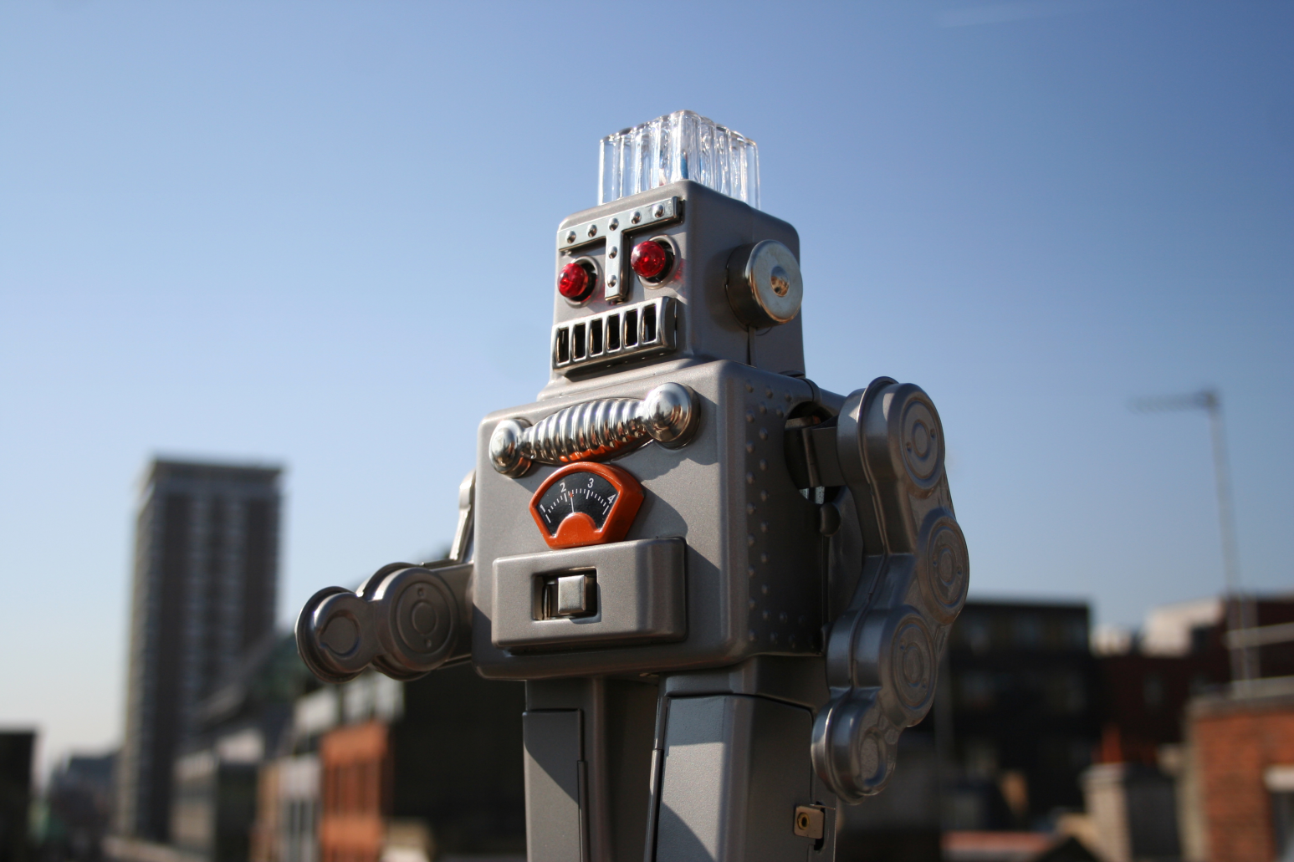

Name: \_\_\_\_\_\_\_\_\_\_\_\_\_\_\_\_\_\_\_\_\_

C:\Users\shirley.vir\Downloads\Copie de CC_2019.png

Introduction

Robots are everywhere. They help us in our everyday tasks and they allow new possibilities. If you could invent a robot to do something for you, what would it do?

* Wash the dishes
* Cook
* Do your bed
* Clean the house
* Do your homework
* Play video games
* Vacuum the floor
* Run errands

Let’s imagine we are in the future. You just received a new robot that can run errands for you. Your robot only knows English and you need to program it.

To be able to program your robot, you will learn about the places around town where it can go, the things it can do for you and the commands you can give it.

Activity 1

On the next page, you will find a list of stores and public places you commonly find in every town. With a partner, try to correctly identify each image.

|  |  |  |
| --- | --- | --- |
| **Word Bank** | | |
| * bakery * bank * butcher’s shop * clothing store * convenience store * drugstore | * video game shop * gas station * hardware store * library * office supply store | * pet shop * post office * restaurant * sports shop * supermarket |

|  |  |
| --- | --- |
| Store or public place | Things you can buy or pick up |
| Two Women At The Supermarket by GDJ |  |
|  |
| Apothecary / pharmacist by Juhele |  |
|  |
| Convenience Stores by oksmith |  |
|  |
| petrol-pump by netalloy |  |
|  |
| Store or public place | Things you can buy or pick up |
| Post office by Rushtini |  |
|  |
| restaurant-15 by PublicDomainSymbols |  |
|  |
| Bank building Icon generic monochrome by jrocha3341 |  |
|  |
| Pet Therapy by Arvin61r58 |  |
|  |
| Store or public place | Things you can buy or pick up |
| # |  |
|  |
| Video Game Controller by dobladov |  |
|  |
| Paperclip Icon by isaiah658 |  |
|  |
| Sports by Jeffryroldan |  |
|  |

|  |  |
| --- | --- |
| Store or public place | Things you can buy or pick up |
| Library Book Cart by SteveLambert |  |
|  |
| Butcher by Juhele |  |
|  |
| Confectioner, pastry-cook by Juhele |  |
|  |
| Clothing Tops by GDJ |  |
|  |

Activity 2

Here is a list of things your robot can do. Write the task it can accomplish in the box next to the appropriate location in Activity 1.

**Example: At the convenience store, the robot can buy chips.**

|  |  |
| --- | --- |
| Buy | * A t-shirt * Fruits and vegetables * Fresh meat * Motor oil * Tools * A baseball bat * A leash for your dog * A stapler * A box of cereals * A cake * Lottery tickets * Construction material * Medication * A tie * Perfume * Fresh bread * Cat food * Swimming goggles * Stamps * A book * A controller |
| Pick up | * A parcel * A food order * A letter * A prescription * A check * A custom cake |

Activity 3

* You will receive three sets of cards.
* First, match each store name with the appropriate image.
* Then, match the object you can buy with the right store.
* Some stores will have more than one object.

**Functional language**

**This card is \_\_\_\_\_\_\_\_\_\_\_\_\_\_\_\_\_\_** .

**It probably goes with \_\_\_\_\_\_\_\_\_\_\_\_\_\_\_\_ .**

**What do you think?**

**I think you’re right!**

**Okay, let’s do another one for now**.

**No, I think it goes with this one.**

Activity 4: Getting Around / Functional Language

You will work in teams of 2. Each of you has an incomplete city map with different information missing. Use the questions at the bottom of your map to ask your partner the information you need to complete your map with the missing locations.

**Don’t look at your partner’s map!**

Directions vocabulary

|  |  |  |  |
| --- | --- | --- | --- |
| Road Crossing Turn Right by MaSc | Turn right | Stop Sign by palomaironique | Stop at |
| Road Crossing Turn Left by MaSc | Turn left | Go Next Arrow Icon by sixsixfive | Go to |
| Road Straight Ahead by MaSc | Go straight | Road sign template by jhnri4 | On *Maple* Street |
| Road Crossing Straight Ahead by MaSc | Go past |  |  |

Activity 6 – Let’s practice

Part 1: After exploring the codes with your teacher, it’s time to practice.

Your teacher will give you a map of a city. Draw the codes in the blank spaces to follow these instructions:

* The robot starts from your house.
* It quickly goes straight to the hardware store and stops to buy light bulbs.
* It turns right two times and stops at the video game shop.
* After, it turns left.
* It goes straight to the gas station and stops to fill up the gas tank.
* It stops again at the bank to withdraw some money and at the drugstore to pick up a prescription.
* It turns left two times and stops at the office supply store to buy some paper.
* It turns left then goes straight to the post office.
* It stops to pick up a parcel.
* It turns right and slowly goes back to your house.

**Codes to use**

**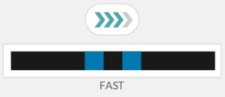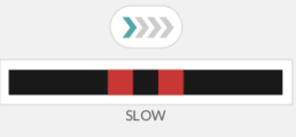**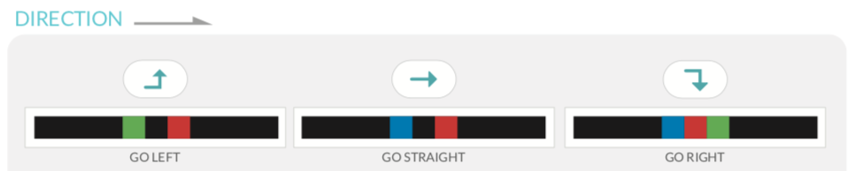

Part 2: On another day, you send your robot to do errands again. You have to complete the map again, but this time you don’t have the blank spaces.

* The robot starts from your house.
* It goes to the pet shop and stops to buy some dog food.
* Past the pet shop, it turns left and goes straight to the clothing store. It stops to buy a pair of socks.
* It turns right after the gas station and quickly goes to the library. It stops at the library to buy a book.
* It turns right after the drugstore. It continues and stops at the bakery to buy some bread.
* It turns right after the bakery and goes very fast down the street.
* It turns right after the sports shop and then it turns left.
* It stops at the supermarket to buy a can of soup.
* After the supermarket, it goes back to your house.

Tip: Use strips of paper to colour your code and place it where it goes on the black line. If you make a mistake, it’s easier to correct it.

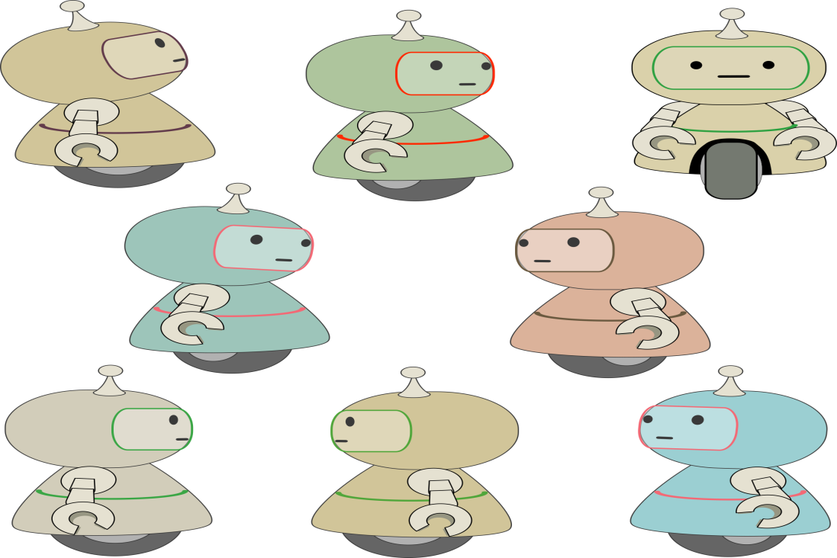

Activity 7 – Code Your Robot

In this activity, you will create your own city map. Then, you will write directions for your robot and it will run errands for you. Follow these steps.

1. Draw a city map that includes the 16 different stores that you know. Also include your house. Make sure the space between the buildings is large enough.
2. Use your map to write sentences to give directions to your robot (p.12). You can look at activity 6 as a model.

* Write 8 to 10 sentences.
* Your robot should stop at 6 or more different places.
* Write what your robot has to buy or pick up.
* Your directives should include: *turn right*, *turn left*, *go straight*, *quickly* and *slowly.*

1. Now that your itinerary is ready, draw the lines and the color codes that your robot will follow on your map.
2. Prepare the *fill in the blank*: Go back to the directives for your robot. Rewrite your set of directives (p.13), but, in each sentence, remove one of the following. There is a model on page 14 to help you.
   * A verb of direction (turn right/left, go straight, stop…)
   * The name of a place
3. Hand in the following to your teacher who will assign you a number.

* Your city map
* Your directives for the robot
* Your directives with blanks

Activity 7: Robot Coding – Final Copy

* \_\_\_\_\_\_\_\_\_\_\_\_\_\_\_\_\_\_\_\_\_\_\_\_\_\_\_\_\_\_\_\_\_\_\_\_\_\_\_\_\_\_\_\_\_\_\_\_\_\_\_\_\_\_\_\_\_\_\_\_\_\_\_\_\_\_\_\_\_\_\_\_\_\_\_\_\_\_\_\_\_\_\_\_\_\_\_\_\_\_\_\_\_\_\_\_\_\_\_\_\_\_\_\_\_\_\_\_\_\_\_\_\_\_\_\_\_\_\_\_\_\_\_\_\_\_\_\_\_\_
* \_\_\_\_\_\_\_\_\_\_\_\_\_\_\_\_\_\_\_\_\_\_\_\_\_\_\_\_\_\_\_\_\_\_\_\_\_\_\_\_\_\_\_\_\_\_\_\_\_\_\_\_\_\_\_\_\_\_\_\_\_\_\_\_\_\_\_\_\_\_\_\_\_\_\_\_\_\_\_\_\_\_\_\_\_\_\_\_\_\_\_\_\_\_\_\_\_\_\_\_\_\_\_\_\_\_\_\_\_\_\_\_\_\_\_\_\_\_\_\_\_\_\_\_\_\_\_\_\_\_
* \_\_\_\_\_\_\_\_\_\_\_\_\_\_\_\_\_\_\_\_\_\_\_\_\_\_\_\_\_\_\_\_\_\_\_\_\_\_\_\_\_\_\_\_\_\_\_\_\_\_\_\_\_\_\_\_\_\_\_\_\_\_\_\_\_\_\_\_\_\_\_\_\_\_\_\_\_\_\_\_\_\_\_\_\_\_\_\_\_\_\_\_\_\_\_\_\_\_\_\_\_\_\_\_\_\_\_\_\_\_\_\_\_\_\_\_\_\_\_\_\_\_\_\_\_\_\_\_\_\_
* \_\_\_\_\_\_\_\_\_\_\_\_\_\_\_\_\_\_\_\_\_\_\_\_\_\_\_\_\_\_\_\_\_\_\_\_\_\_\_\_\_\_\_\_\_\_\_\_\_\_\_\_\_\_\_\_\_\_\_\_\_\_\_\_\_\_\_\_\_\_\_\_\_\_\_\_\_\_\_\_\_\_\_\_\_\_\_\_\_\_\_\_\_\_\_\_\_\_\_\_\_\_\_\_\_\_\_\_\_\_\_\_\_\_\_\_\_\_\_\_\_\_\_\_\_\_\_\_\_\_
* \_\_\_\_\_\_\_\_\_\_\_\_\_\_\_\_\_\_\_\_\_\_\_\_\_\_\_\_\_\_\_\_\_\_\_\_\_\_\_\_\_\_\_\_\_\_\_\_\_\_\_\_\_\_\_\_\_\_\_\_\_\_\_\_\_\_\_\_\_\_\_\_\_\_\_\_\_\_\_\_\_\_\_\_\_\_\_\_\_\_\_\_\_\_\_\_\_\_\_\_\_\_\_\_\_\_\_\_\_\_\_\_\_\_\_\_\_\_\_\_\_\_\_\_\_\_\_\_\_\_
* \_\_\_\_\_\_\_\_\_\_\_\_\_\_\_\_\_\_\_\_\_\_\_\_\_\_\_\_\_\_\_\_\_\_\_\_\_\_\_\_\_\_\_\_\_\_\_\_\_\_\_\_\_\_\_\_\_\_\_\_\_\_\_\_\_\_\_\_\_\_\_\_\_\_\_\_\_\_\_\_\_\_\_\_\_\_\_\_\_\_\_\_\_\_\_\_\_\_\_\_\_\_\_\_\_\_\_\_\_\_\_\_\_\_\_\_\_\_\_\_\_\_\_\_\_\_\_\_\_\_
* \_\_\_\_\_\_\_\_\_\_\_\_\_\_\_\_\_\_\_\_\_\_\_\_\_\_\_\_\_\_\_\_\_\_\_\_\_\_\_\_\_\_\_\_\_\_\_\_\_\_\_\_\_\_\_\_\_\_\_\_\_\_\_\_\_\_\_\_\_\_\_\_\_\_\_\_\_\_\_\_\_\_\_\_\_\_\_\_\_\_\_\_\_\_\_\_\_\_\_\_\_\_\_\_\_\_\_\_\_\_\_\_\_\_\_\_\_\_\_\_\_\_\_\_\_\_\_\_\_\_
* \_\_\_\_\_\_\_\_\_\_\_\_\_\_\_\_\_\_\_\_\_\_\_\_\_\_\_\_\_\_\_\_\_\_\_\_\_\_\_\_\_\_\_\_\_\_\_\_\_\_\_\_\_\_\_\_\_\_\_\_\_\_\_\_\_\_\_\_\_\_\_\_\_\_\_\_\_\_\_\_\_\_\_\_\_\_\_\_\_\_\_\_\_\_\_\_\_\_\_\_\_\_\_\_\_\_\_\_\_\_\_\_\_\_\_\_\_\_\_\_\_\_\_\_\_\_\_\_\_\_
* \_\_\_\_\_\_\_\_\_\_\_\_\_\_\_\_\_\_\_\_\_\_\_\_\_\_\_\_\_\_\_\_\_\_\_\_\_\_\_\_\_\_\_\_\_\_\_\_\_\_\_\_\_\_\_\_\_\_\_\_\_\_\_\_\_\_\_\_\_\_\_\_\_\_\_\_\_\_\_\_\_\_\_\_\_\_\_\_\_\_\_\_\_\_\_\_\_\_\_\_\_\_\_\_\_\_\_\_\_\_\_\_\_\_\_\_\_\_\_\_\_\_\_\_\_\_\_\_\_\_

Activity 8: Robot Coding – Fill in the Blank

number

\_\_\_\_\_\_

* \_\_\_\_\_\_\_\_\_\_\_\_\_\_\_\_\_\_\_\_\_\_\_\_\_\_\_\_\_\_\_\_\_\_\_\_\_\_\_\_\_\_\_\_\_\_\_\_\_\_\_\_\_\_\_\_\_\_\_\_\_\_\_\_\_\_\_\_\_\_\_\_\_\_\_\_\_\_\_\_\_\_\_\_\_\_\_\_\_\_\_\_\_\_\_\_\_\_\_\_\_\_\_\_\_\_\_\_\_\_\_\_\_\_\_\_\_\_\_\_\_\_\_\_\_\_\_\_\_\_
* \_\_\_\_\_\_\_\_\_\_\_\_\_\_\_\_\_\_\_\_\_\_\_\_\_\_\_\_\_\_\_\_\_\_\_\_\_\_\_\_\_\_\_\_\_\_\_\_\_\_\_\_\_\_\_\_\_\_\_\_\_\_\_\_\_\_\_\_\_\_\_\_\_\_\_\_\_\_\_\_\_\_\_\_\_\_\_\_\_\_\_\_\_\_\_\_\_\_\_\_\_\_\_\_\_\_\_\_\_\_\_\_\_\_\_\_\_\_\_\_\_\_\_\_\_\_\_\_\_\_
* \_\_\_\_\_\_\_\_\_\_\_\_\_\_\_\_\_\_\_\_\_\_\_\_\_\_\_\_\_\_\_\_\_\_\_\_\_\_\_\_\_\_\_\_\_\_\_\_\_\_\_\_\_\_\_\_\_\_\_\_\_\_\_\_\_\_\_\_\_\_\_\_\_\_\_\_\_\_\_\_\_\_\_\_\_\_\_\_\_\_\_\_\_\_\_\_\_\_\_\_\_\_\_\_\_\_\_\_\_\_\_\_\_\_\_\_\_\_\_\_\_\_\_\_\_\_\_\_\_\_
* \_\_\_\_\_\_\_\_\_\_\_\_\_\_\_\_\_\_\_\_\_\_\_\_\_\_\_\_\_\_\_\_\_\_\_\_\_\_\_\_\_\_\_\_\_\_\_\_\_\_\_\_\_\_\_\_\_\_\_\_\_\_\_\_\_\_\_\_\_\_\_\_\_\_\_\_\_\_\_\_\_\_\_\_\_\_\_\_\_\_\_\_\_\_\_\_\_\_\_\_\_\_\_\_\_\_\_\_\_\_\_\_\_\_\_\_\_\_\_\_\_\_\_\_\_\_\_\_\_\_
* \_\_\_\_\_\_\_\_\_\_\_\_\_\_\_\_\_\_\_\_\_\_\_\_\_\_\_\_\_\_\_\_\_\_\_\_\_\_\_\_\_\_\_\_\_\_\_\_\_\_\_\_\_\_\_\_\_\_\_\_\_\_\_\_\_\_\_\_\_\_\_\_\_\_\_\_\_\_\_\_\_\_\_\_\_\_\_\_\_\_\_\_\_\_\_\_\_\_\_\_\_\_\_\_\_\_\_\_\_\_\_\_\_\_\_\_\_\_\_\_\_\_\_\_\_\_\_\_\_\_
* \_\_\_\_\_\_\_\_\_\_\_\_\_\_\_\_\_\_\_\_\_\_\_\_\_\_\_\_\_\_\_\_\_\_\_\_\_\_\_\_\_\_\_\_\_\_\_\_\_\_\_\_\_\_\_\_\_\_\_\_\_\_\_\_\_\_\_\_\_\_\_\_\_\_\_\_\_\_\_\_\_\_\_\_\_\_\_\_\_\_\_\_\_\_\_\_\_\_\_\_\_\_\_\_\_\_\_\_\_\_\_\_\_\_\_\_\_\_\_\_\_\_\_\_\_\_\_\_\_\_
* \_\_\_\_\_\_\_\_\_\_\_\_\_\_\_\_\_\_\_\_\_\_\_\_\_\_\_\_\_\_\_\_\_\_\_\_\_\_\_\_\_\_\_\_\_\_\_\_\_\_\_\_\_\_\_\_\_\_\_\_\_\_\_\_\_\_\_\_\_\_\_\_\_\_\_\_\_\_\_\_\_\_\_\_\_\_\_\_\_\_\_\_\_\_\_\_\_\_\_\_\_\_\_\_\_\_\_\_\_\_\_\_\_\_\_\_\_\_\_\_\_\_\_\_\_\_\_\_\_\_
* \_\_\_\_\_\_\_\_\_\_\_\_\_\_\_\_\_\_\_\_\_\_\_\_\_\_\_\_\_\_\_\_\_\_\_\_\_\_\_\_\_\_\_\_\_\_\_\_\_\_\_\_\_\_\_\_\_\_\_\_\_\_\_\_\_\_\_\_\_\_\_\_\_\_\_\_\_\_\_\_\_\_\_\_\_\_\_\_\_\_\_\_\_\_\_\_\_\_\_\_\_\_\_\_\_\_\_\_\_\_\_\_\_\_\_\_\_\_\_\_\_\_\_\_\_\_\_\_\_\_
* \_\_\_\_\_\_\_\_\_\_\_\_\_\_\_\_\_\_\_\_\_\_\_\_\_\_\_\_\_\_\_\_\_\_\_\_\_\_\_\_\_\_\_\_\_\_\_\_\_\_\_\_\_\_\_\_\_\_\_\_\_\_\_\_\_\_\_\_\_\_\_\_\_\_\_\_\_\_\_\_\_\_\_\_\_\_\_\_\_\_\_\_\_\_\_\_\_\_\_\_\_\_\_\_\_\_\_\_\_\_\_\_\_\_\_\_\_\_\_\_\_\_\_\_\_\_\_\_\_\_
* \_\_\_\_\_\_\_\_\_\_\_\_\_\_\_\_\_\_\_\_\_\_\_\_\_\_\_\_\_\_\_\_\_\_\_\_\_\_\_\_\_\_\_\_\_\_\_\_\_\_\_\_\_\_\_\_\_\_\_\_\_\_\_\_\_\_\_\_\_\_\_\_\_\_\_\_\_\_\_\_\_\_\_\_\_\_\_\_\_\_\_\_\_\_\_\_\_\_\_\_\_\_\_\_\_\_\_\_\_\_\_\_\_\_\_\_\_\_\_\_\_\_\_\_\_\_\_\_\_\_

Fill in the Blank Model

* The robot starts from your house.
* It quickly goes to the \_\_\_\_\_\_\_\_\_\_\_\_\_\_\_ to buy light bulbs.
* It \_\_\_\_\_\_\_\_\_\_\_\_\_\_\_ and stops at the video game shop.
* After, it turns right again and then \_\_\_\_\_\_\_\_\_\_\_\_\_\_\_.
* It goes straight to the \_\_\_\_\_\_\_\_\_\_\_\_\_\_\_ and stops to fill up the gas tank.
* It stops again at \_\_\_\_\_\_\_\_\_\_\_\_\_\_\_ to withdraw some money and at the drugstore to pick up a prescription.
* It \_\_\_\_\_\_\_\_\_\_\_\_\_\_\_ two times and stops at the office supply store to buy some paper.
* It turns left then \_\_\_\_\_\_\_\_\_\_\_\_\_\_\_ to the post office.
* It \_\_\_\_\_\_\_\_\_\_\_\_\_\_\_ to pick up a parcel.
* It \_\_\_\_\_\_\_\_\_\_\_\_\_\_\_ and slowly goes back to your house.

Activity 8: Complete Your Classmate’s Map

With your partner, you will now go around and try completing other city maps.

* On each map, look at the number and find the corresponding *fill in the blank* activity.
* Now, press start on the Ozobot and look at what it is doing.
* Fill in the blank with an appropriate word.
* Use the functional language on the next page to help you speak English only with your partner.

Functional Language

Activity 8



