LES - ENGLISH AS A SECOND LANGUAGE
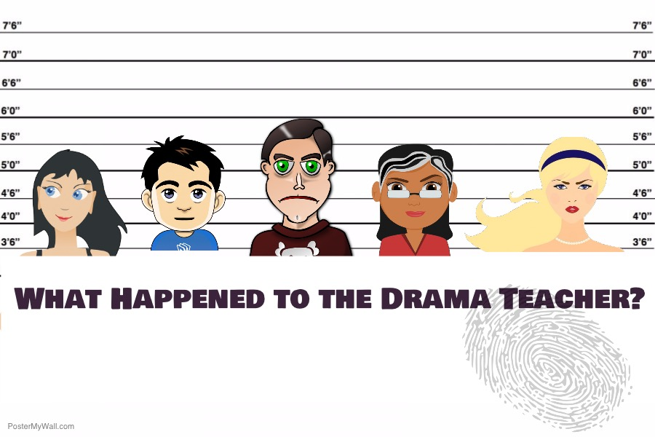
Secondary
STUDENT BOOKLET
Name:__________________________
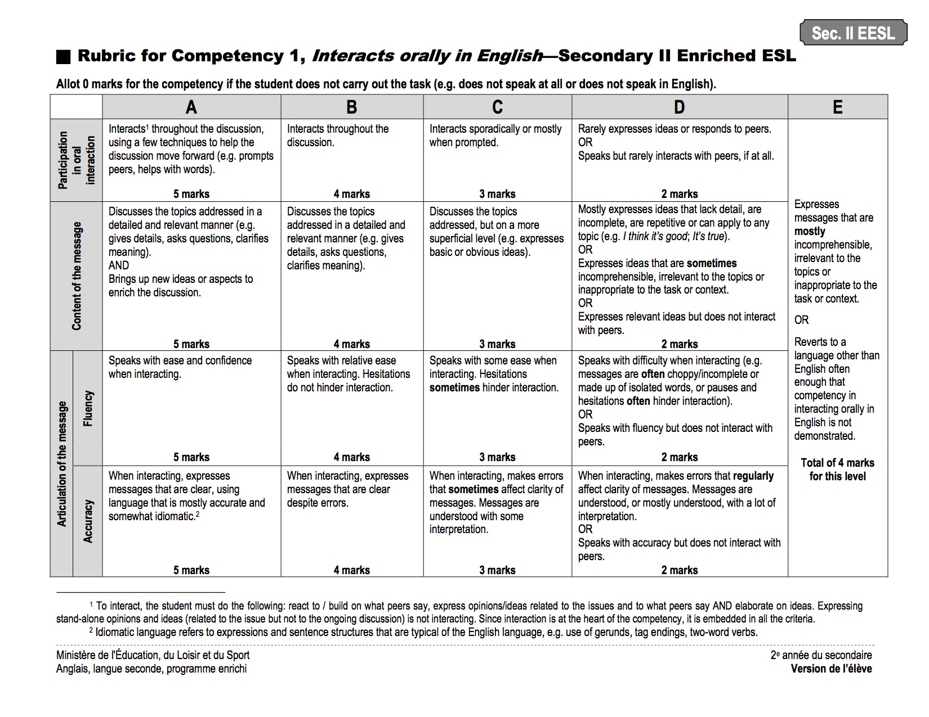
C1 Rubric sec II EESL

The Scenario

Watch the video

What Happened to the Drama Teacher?

The drama teacher, Mr. Ramirez, was discovered unconscious by the school’s janitor backstage in the school auditorium. The janitor found him in this comatose state. No weapons were found on site.

The school’s surveillance camera showed that only 5 people were in the auditorium that night. They were practicing for the school play. All of them were present when the police arrived at 8:15 PM, 15 minutes after Mr. Ramirez was found unconscious, by the janitor.

Each of the individuals had a private conversation with Mr. Ramirez that fateful night. This fact is confirmed by the surveillance camera in the auditorium. Note that Mr. Ramirez had been off-camera since 7:30 PM. These 5 individuals are now identified as the main suspects.
In addition to these facts, we were informed that all 5 of the suspects had a particular relationship with the victim.

Mr Ramirez
Task 1 - You are now a suspect in this investigation

- Read the information on the suspect card you received.
- Consult the chart, Summary of Events.
- Identify the information that will be helpful to plan your Digital Story. Complete the grid with keywords.
TEXT INFORMATION | PERTINENT INFORMATION
MAIN CHARACTER
Identification of the suspect
Occupation of the suspect
SETTING
Arrival time at the auditorium (See Summary of Events)
Reason(s) for being at the auditorium
Connection to the victim
PROBLEM
Nature of the conversation with the victim (infer)
POSSIBLE SOLUTIONS
Alibi - Explanation of time off camera
Accusation of another suspect and reasons for this accusation

TASK 2 - The Hall Monitor
- Listen to the two versions of Leila’s digital story.
- Complete the grid with the specific characteristics of each of these digital stories.

Leila’s Suspect Card

Background
Time period: 5:50 PM—Filmed conversation: 6:00—6:10 PM
Location: Window of opportunity: 7:50—8:00 PM

Description
Personality: Quiet, shy and mysterious. She roams the halls every day and knows everything about everyone.
Significance: Mr. Ramirez and Leila briefly dated a few years ago.

Motivation
Problem: Leila has been stealing from the teacher’s room, and Mr. Ramirez found out she was doing that. He warned her that she had to stop otherwise he would tell Ms. Dane about it.
Outcome: Leila is already on probation and if Ramirez went to Dane, she might lose her job. She wants him not to reveal her secret.

Memorable Moments
Quote: “Ramirez wants to throw me under the bus, but he is no angel.”
Interesting Fact: Ms. Dane was never pleased with Mr. Ramirez’s work.

Personal Connection
Impression: “Mr. Ramirez looked very nervous and distracted when he saw Ms. Dane enter the auditorium.”
Connection: Your turn to make links!
Leila - Hall Monitor

Characteristics of a Statement

Elements of a Digital Story | Explanation | Text 1 - Leila’s Statement 1 | Text 2 - Leila’s Statement 2
Point of view/ Dramatic question | The main point the narrator tries to communicate, or key question that will be answered by the end of the story.
Emotional content  (Written Language) | Writing that will take hold of audience’s attention and engage them emotionally.
Voice  (Spoken Language) | Emotion, intonation and inflection that the narrator uses to give greater meaning to the story.
Music | Thoughtfully selected sounds and music.
Visuals | Many stories can be illustrated effectively with a small number of images or video, and a fairly short text.
Rythm of the story | The rhythm of a story and how slowly or quickly it moves.
Believability and appreciation | Was the story believable?  Was the story well-made?  Was the story informative?

______________________________________________________________________________
______________________________________________________________________________
______________________________________________________________________________
______________________________________________________________________________
______________________________________________________________________________
______________________________________________________________________________
______________________________________________________________________________
______________________________________________________________________________
______________________________________________________________________________
______________________________________________________________________________
______________________________________________________________________________
______________________________________________________________________________
______________________________________________________________________________
______________________________________________________________________________
______________________________________________________________________________
______________________________________________________________________________
______________________________________________________________________________
______________________________________________________________________________
______________________________________________________________________________
______________________________________________________________________________
____________________________________________________________________________________________________________________________________________________________

TASK 3a - Write Your Statement (double spaced)

______________________________________________________________________________
______________________________________________________________________________
______________________________________________________________________________
______________________________________________________________________________
______________________________________________________________________________
______________________________________________________________________________
______________________________________________________________________________
______________________________________________________________________________
______________________________________________________________________________
______________________________________________________________________________
______________________________________________________________________________
______________________________________________________________________________
______________________________________________________________________________
______________________________________________________________________________
______________________________________________________________________________
______________________________________________________________________________
______________________________________________________________________________
______________________________________________________________________________
______________________________________________________________________________
______________________________________________________________________________
____________________________________________________________________________________________________________________________________________________________

Task 3b – Peer Feedback and Revising Your Statement
- Read the text once to get a general idea. Do not write any notes on the text.
- Read the text a second time in order to provide feedback. You may use sticky notes.
- Answer the questions on the Peer Feedback Card.
- Pass your text to another person in your team.
- The new reader follows the same procedure and adds new comments only.
- Return the text to its original owner.

Revising Your Statement

- Decide which suggestions/comments you will accept and integrate into your text.
- Make the necessary changes (e.g. delete unnecessary parts, add missing details, correct grammar, punctuation and spelling mistakes).

 Reviewer’s name: ____________________________________________________________
Peer Feedback Card | Consider these questions about the text.  Check off the elements that need work.  - Does the text achieve the intended purpose? (to persuade)  - Is the text written with the intended audience in mind? (Police investigators)  - Is the information accurate?  - Does it make sense?  - Is the message logical?  - Is the message clear?  - Is the message well-articulated?  - Should some information/ideas be rearranged?  - Are there sufficient facts, examples and explanations?  - Should any information/ideas be added?  - Is there a lot of repetition? Should some information/ideas be deleted?  - Is any important information missing?  - Does the grammar, punctuation or spelling need work? | What did I like about the text?
 |  | Two questions/comments :
 |  | Two suggestions for improvement:
Adapted from: Peer Feedback in the Writing Process, Working Document - Fall 2015 - MELS

 Reviewer’s name: ____________________________________________________________
Peer Feedback Card | Consider these questions about the text.  Check off the elements that need work.  - Does the text achieve the intended purpose? (to persuade)  - Is the text written with the intended audience in mind? (Police investigators)  - Is the information accurate?  - Does it make sense?  - Is the message logical?  - Is the message clear?  - Is the message well-articulated?  - Should some information/ideas be rearranged?  - Are there sufficient facts, examples and explanations?  - Should any information/ideas be added?  - Is there a lot of repetition? Should some information/ideas be deleted?  - Is any important information missing?  - Does the grammar, punctuation and spelling need work? | What did I like about the text?
 |  | Two questions/comments:
 |  | Two suggestions for improvement:

Make appropriate corrections to your statement taking your peers’ feedback into account.

Task 4– Plan your Storyboard

Frame # ______ and Description | Media and other details  (images, music, voice, rhythm, etc.)
Narration (text)
Frame # ______ and Description | Media and other details  (images, music, voice, rhythm, etc.)
Narration (text)

Frame # ______ and Description | Media and other details  (images, music, voice, rhythm, etc.)
Narration (text)
Frame # ______ and Description | Media and other details  (images, music, voice, rhythm, etc.)
Narration (text)

Frame # ______ and Description | Media and other details  (images, music, voice, rhythm, etc.)
Narration (text)
Frame # ______ and Description | Media and other details  (images, music, voice, rhythm, etc.)
Narration (text)

Frame # ______ and Description | Media and other details  (images, music, voice, rhythm, etc.)
Narration (text)
Frame # ______ and Description | Media and other details  (images, music, voice, rhythm, etc.)
Narration (text)

TASK 5- Record your Statement

Prepare the pictures that you need for your digital story. You can find some on the Internet (be careful about copyrights - you can use pixabay.com), take your own photos or you can use the pictures available (recit.org/ul/per) in this learning situation.
Use one of these apps to create your statement. Don’t forget to take into account the elements of a digital story.
iOS Android

Adobe Spark Video
WeVideo Lensoo Create

TASK 6- Who is the Accused Person?

Listen/view carefully to the different statements. Who do you think should be the accused person? Write down arguments to support your accusation.

________________________________________________________________________________________________________________________________________________________________________________________________________________________________________________________________________________________________________________________________________________________________________________________________________________________________________________________________________________________________________________________

