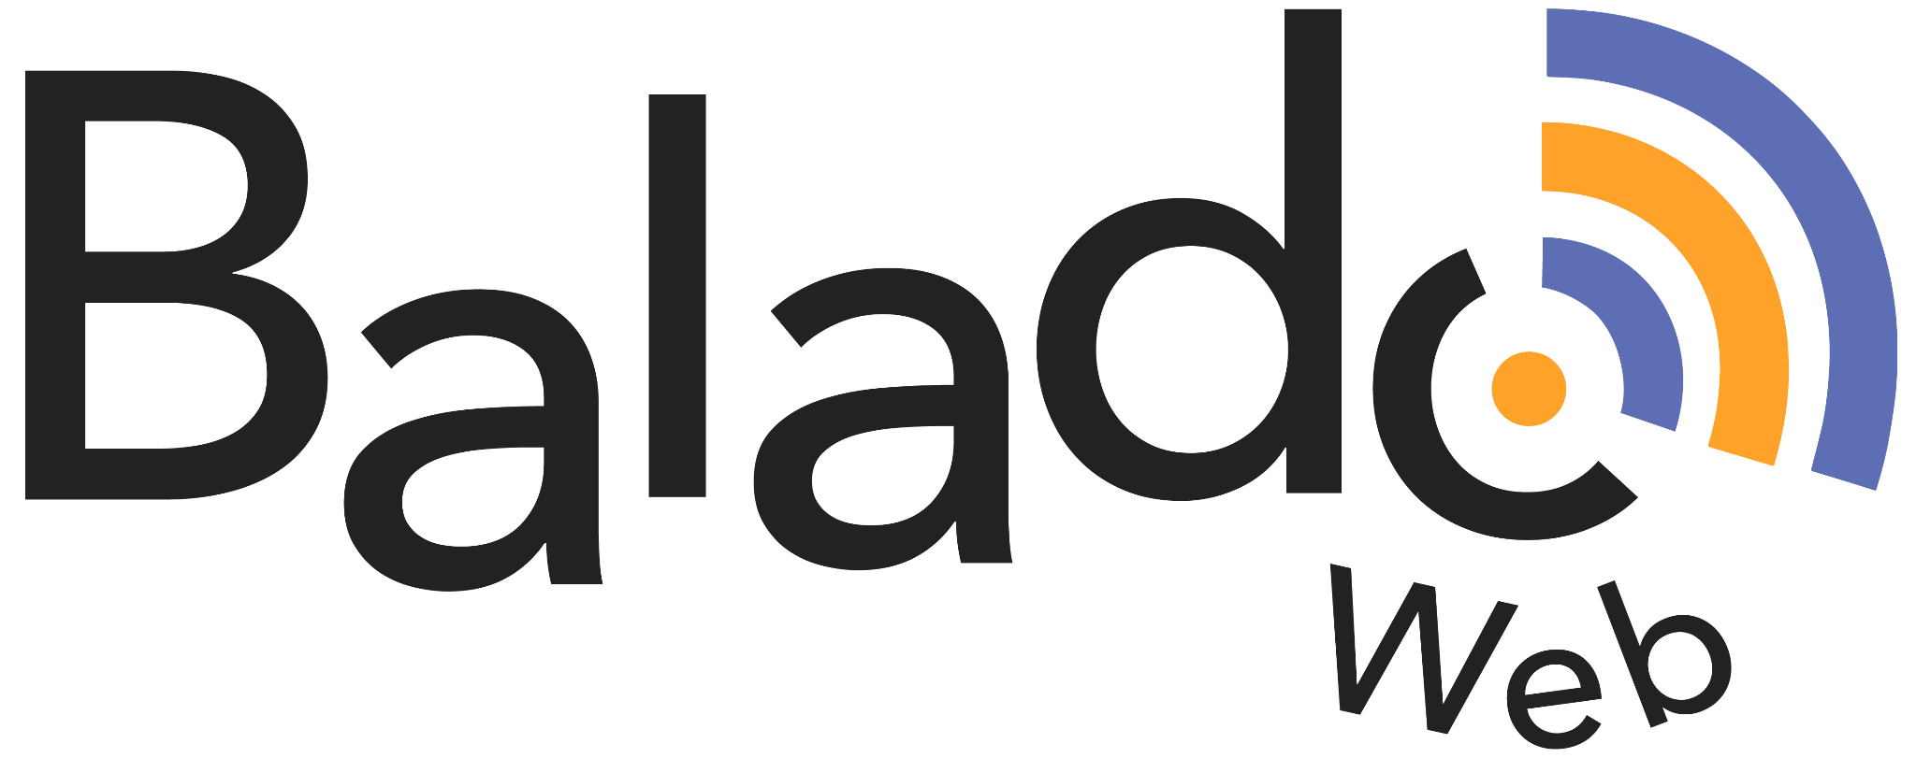

Student Booklet
Name:

Service national du RÉCIT, domaine des langues

Step 1: What is a podcast?

- After watching the video presented in class, complete your notes.

- Listen to various podcasts to understand their structure. Select two podcasts and complete the listening grid on pages 2 and 3 after each one.
https://www.scientificamerican.com/podcast/60-second-science/  (7:07) | Marché Bonsecours (students)  (English Version)  (0:47) | Why are giraffe tongues blue? (4:44)

- Use the following listening grids after listening to each podcast.

Podcast: ______________________

- What type of podcast is it?  - Audio podcast  - Enriched podcast  - What do you think about the length of the podcast?  - Adequate  - Too long  - Too short  - Is it easy to identify the structure (parts) of the podcast?  - Yes  - No  - Partially  - How would you describe the podcast's intro and outro (beginning and end)?  - Musical  - Narrative  - Both  - Non-existent | - Rate the quality of these aspects of the podcast. Evaluate on a scale of 1 to 5.  Voice and music are well-balanced.  - Totally agree  - Agree  - Somewhat agree  - Disagree  - Totally disagree  The rhythm is well-adjusted to the content.  - Totally agree  - Agree  - Somewhat agree  - Disagree  - Totally disagree  The intro is pertinent and catchy.  - Totally agree  - Agree  - Somewhat agree  - Disagree  - Totally disagree  Integrated sound (if any) is relevant to the content.  - Totally agree  - Agree  - Somewhat agree  - Disagree  - Totally disagree

Podcast: ________________________________

- What type of podcast is it?  - Audio podcast  - Enriched podcast  - What do you think about the length of the podcast?  - Adequate  - Too long  - Too short  - Is it easy to identify the structure (parts) of the podcast?  - Yes  - No  - Partially  - How would you describe the podcast's intro and outro (beginning and end)?  - Musical  - Narrative  - Both  - Non-existent | - Rate the quality of these aspects of the podcast. Evaluate on a scale of 1 to 5.  Voice and music are well-balanced.  - Totally agree  - Agree  - Somewhat agree  - Disagree  - Totally disagree  The rhythm is well-adjusted to the content.  - Totally agree  - Agree  - Somewhat agree  - Disagree  - Totally disagree  The intro is pertinent and catchy.  - Totally agree  - Agree  - Somewhat agree  - Disagree  - Totally disagree  Integrated sound (if any) is relevant to the content.  - Totally agree  - Agree  - Somewhat agree  - Disagree  - Totally disagree

- Analyze the structure of a podcast.
Select one podcast from the provided list (page 1). Use the following guiding questions to analyze the structure of a podcast.

 | Text | Audio
Opening signature: Music jingle and/or voice | Is there an introductory text? | Is there an introductory musical signature?  An ambient sound? Sound effects?
Introduction | What is the intention of the podcast?  - To inform  - To convince  - To entertain  - To persuade  Who is the intended audience?  Is there a sentence to introduce the topic? If so, what type is it? (declarative, interrogative or exclamatory)?  Does the host present himself or herself?  Does a guest accompany the host? If so, were they introduced? | Is there an ambient sound? Sound effects?
Development | What are the subtopics?  What type of sentences are used the most?  Which language register is mainly used?  Do the speakers vary their speed? If so, when do they choose to slow down or accelerate? Does it affect comprehension?  Does the speaker use strategies to stimulate the interest of his/her audience? Which ones? | Is there a musical signature during transitions? An ambient sound? Sound effects?
Conclusion | Is there a sentence in the podcast that indicates it is close to ending?  Is there a summary of the content of the podcast at the end?  Is there a sentence addressed to listeners? | Is there a concluding musical signature?  An ambient sound? Sound effects?

Step 2: Research Your Podcast Topic

- What is the topic of your podcast?

- Plan your podcast.

- What is my intention?
To entertain, to inform, to convince…
- Who is my targeted audience?
Peers, children, adults, etc.
- What are the available resources?
librarians, books, computers, iPad, libraries, etc.
- What are the different steps to follow?
Establish a calendar
- What is the expected production?
A podcast

- What would you like to learn about this topic? Highlight the most important words.

- Formulate a research question.

Example: How does being in high school affect our social life?

- Write the highlighted words from your list. Find synonyms for each word. This will help you with your research.

Highlighted Words | Synonyms

- Make sure you select reliable information. Use this grid for each source.

Name of the website: | Your Evaluation
WHO is the author? (AUTHORITY) | ★ ★★ ★★★
- Is it an individual or a known organization?  - Is the author an expert in this field?  - Can I contact the author? | □  □  □
WHAT is this source about? (RELEVANCE AND ACCURACY) | ★ ★★ ★★★
- Is the topic of the website clearly mentioned on the main page?  - Is the information relevant to my research?  - Is the information accurate and confirmed by at least two other sources of information (print or digital)?  - Are the sources of information credible, serious and cited on the site?  - Are there links to other serious sites on the same topic? | □  □  □  □  □
WHEN was the site published (CURRENT) | ★ ★★ ★★★
- Is the information on the website up to date?  - Are the links to other sites working and up to date? | □  □
WHY is the information published? (OBJECTIVITY) | ★ ★★ ★★★
- What kind of information am I looking for?___________________________________  - What is the goal of the website?_______________________________________  - Is the information impartial?  - For controversial topics, are different perspectives presented? Are the arguments serious? | □  □
WHERE does the information come from? (SOURCE) | ★ ★★ ★★★
- Is the information provided by an individual or an organization? Write their  name : ________________  - Is the information linked to a place related to the topic of my research? | □
HOW is information presented? (CLARITY AND RIGOR) | ★ ★★ ★★★
- Is it easy to find the information needed?  - Is there an internal search tool?  - Are the texts and media clearly presented and easy to consult?  - Are the texts written in quality English?  - If any, are the ads separate from the content of the website? | □  □  □  □  □
Global evaluation of the website | ★ ★★ ★★★

Globally, does the website earn at least 2 stars?

Is the information relevant to the topic of my research?

Is the information reliable and confirmed by the two other sources?

If my question is “yes” to these three questions, I can use the website as a source for my research.

- Use the following chart to write down the information found. Write down key words.

Research question:
Source 1: | Source 2: | Source 3:

Step 3: Plan and Write Your Script

- Use the key words from your research to plan your script

Keep in mind these elements of a successful podcast script.
- Reduced or Condensed Content  - About 100 to 135 spoken words per minute. | - Language and Style  - Use contractions to sound more natural  - Use descriptive or visual language  - Use short sentences  - Use simple words  - Restrict the use of pronouns

Opening signature  Music jingle and/or voice  Duration: ( ___ ) |  | Sound | Image
Introduction  Duration:  ( ___ ) | Set the stage for your podcast. State the podcast title, who you are, etc. Introduce the main topic.
Development  Duration:  ( ___ ) | Develop the main topic.
Closing remarks or recap  Duration:  ( ___ ) | Conclude the subject.  Invite to reflect or take action.
Closing signature
Music jingle and/or voice
Duration: ( ___ )

- Write the script of your podcast. Once it’s been verified by your teacher, annotate your text to practice delivery.

Remember:
- Divide sentences to group each idea and mark a pause.
- Put focus words in bold that will be emphasized during delivery. Usually, the key ideas of the sentence.
- Write large numbers in letters to avoid hesitation.

Step 4: Practice Your Podcast Delivery
- Use one of the following tools to practice the delivery of your text. Listen to or have another student listen to your podcast and make your final adjustments.
Vocaroo | Cloud Audio Recorder | Windows Voice Recorder

Things to listen for:

- Is my pronunciation clear?
- Is the rhythm appropriate?
- Is the intonation engaging?

Step 5: Record and Edit Your Podcast
You are now ready to record and edit your podcast! Before you use images or sounds, make sure you read and respect the following.

Rules and responsibilities | Images, sound clips and quotes respect copyright. Any required authorizations should be mentioned in the description of the podcast.
 | The content respects the rights and integrity of individuals (no racist, sexist or damaging comments, etc.).
 | The content does not disclose personal information (last name, phone number, address, etc.).

You are almost there! Before you start recording your podcast, we invite you to listen to the video How to sound great (3:38) which will give you tips to improve your sound even if you are in a school with a lot of noise!

Tools to record your podcast

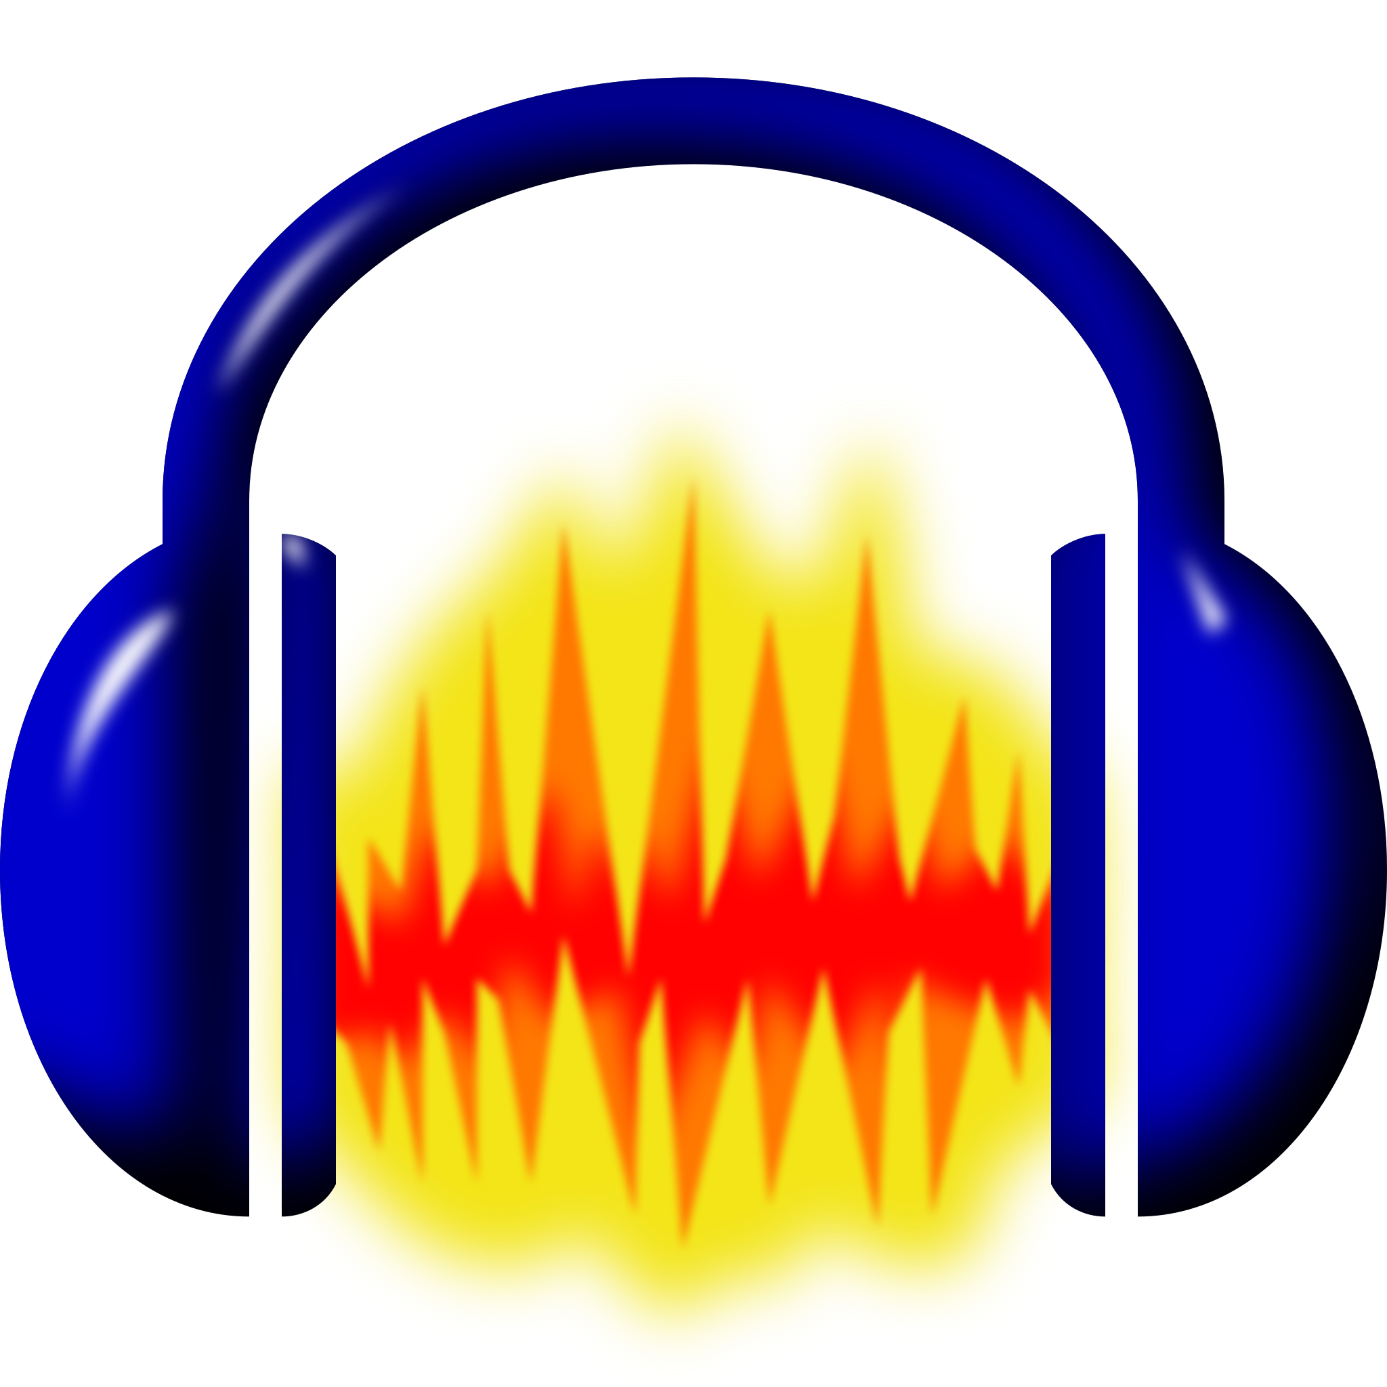  Audacity | BandLab Education | Anchor

Tools to find copyright-free images and sound

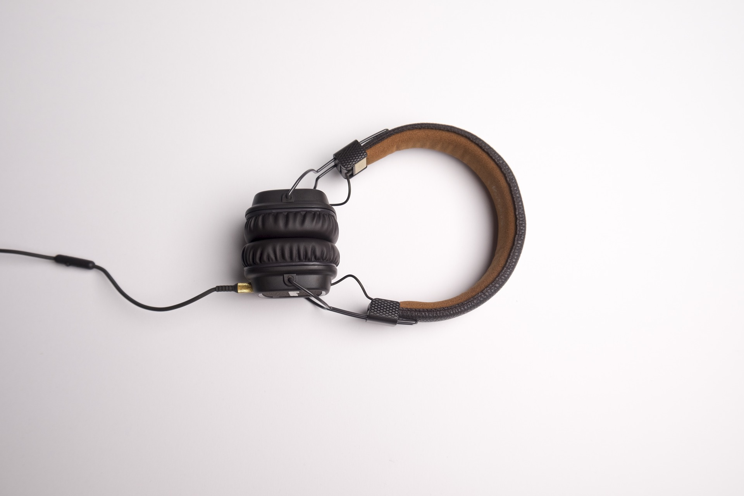  Sound Banks | Image Banks

Step 6: Publish Your Podcast
Before you post, check these criteria and modify your podcast accordingly.
- What type of podcast is it?  - Audio podcast  - Enriched podcast  - What do you think about the length of the podcast?  - Adequate  - Too long  - Too short  - Is it easy to identify the structure (parts) of the podcast?  - Yes  - No  - Partially  - How would you describe the podcast's intro and outro (beginning and end)?  - Musical  - Narrative  - Both  - Non-existent | - Rate the quality of these aspects of your podcast. Evaluate on a scale of 1 to 5.  Voice and music are well-balanced.  - Totally agree  - Agree  - Somewhat agree  - Disagree  - Totally disagree  The rhythm is well-adjusted to the content.  - Totally agree  - Agree  - Somewhat agree  - Disagree  - Totally disagree  The intro is pertinent and catchy.  - Totally agree  - Agree  - Somewhat agree  - Disagree  - Totally disagree  Integrated sound (if any) is relevant to the content.  - Totally agree  - Agree  - Somewhat agree  - Disagree  - Totally disagree
Quality of the content | Comments
The content of the podcast allows people to quickly grasp the subject.
The content is created with the audience in mind.
The content of the podcast is accessible and reflects the quality of the language (prosodic elements).
Your podcast is now ready to be published! Before it is online, make sure you prepare a short description of your podcast. You will also need to write only your first name, and provide an address for your podcast.

Title of my podcast:

Description:

Your teacher will provide you with a class code and a group number in order to post your podcast on the BaladoWeb platform.

You can also watch this quick tutorial to find out how to post your podcast on the site.

