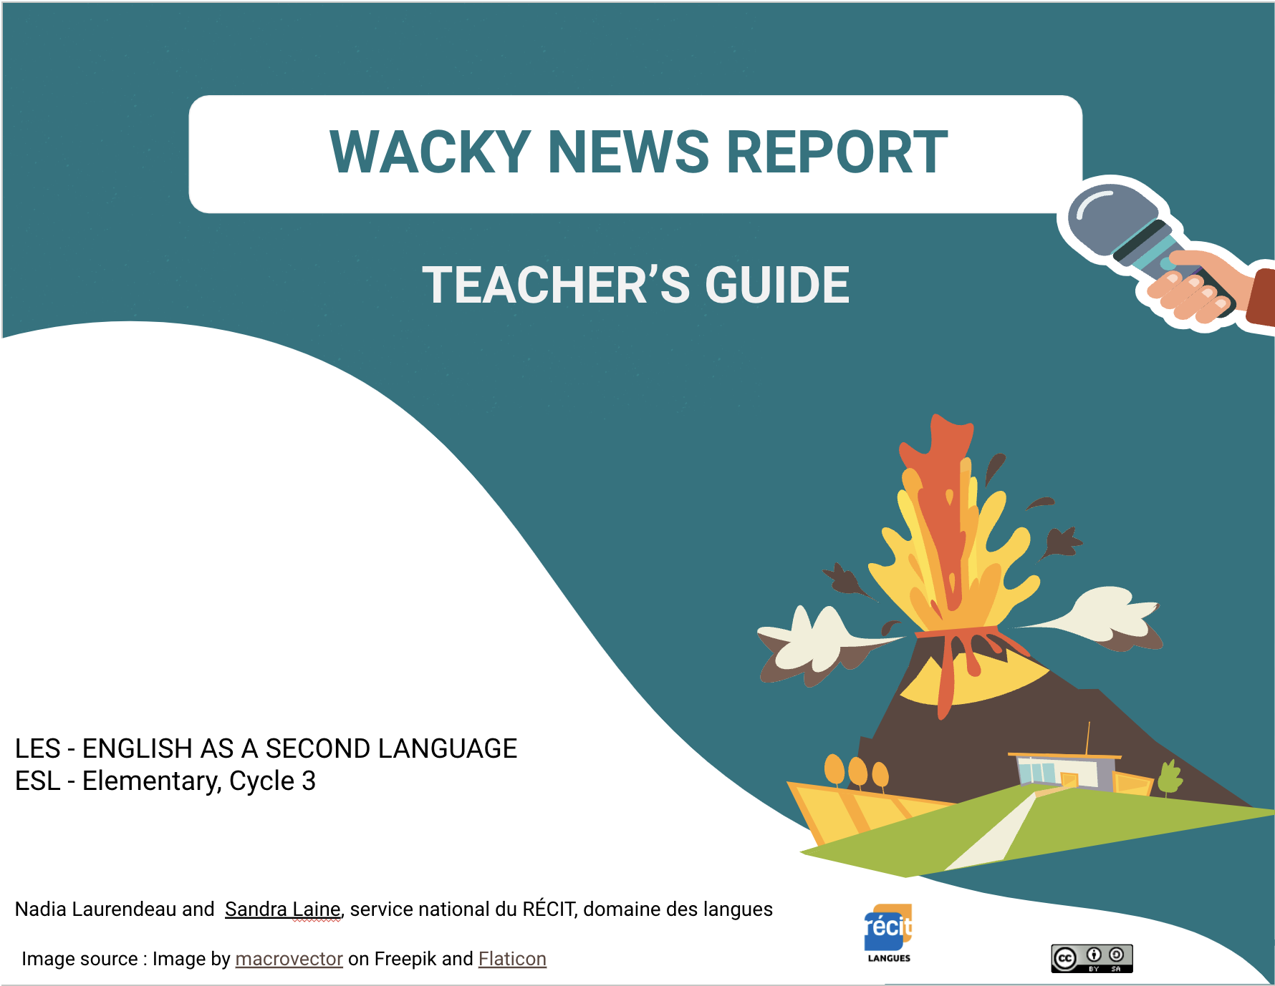
Updated, October 2026
Overview of the Learning Situation
Goal
Reinvest information learned about meteorological phenomena to produce a wacky weather news report using My Talking Avatar or Voki.

Links with the program
Competencies
Interacts orally in English | Participation in exchanges  Use vocabulary and useful expressions
Reinvests understanding of texts | Demonstration of understanding  Use of knowledge from texts in a reinvestment task
Writes texts | Characteristics of a written text  Application of targeted language conventions
Vocabulary
- Weather
- Natural disasters
- Weather report
- Question words
Grammar


- Verbs in the simple past are to be reviewed prior to doing this LES
Applications | Technology | Material
   | - Speakers  - Tablets  - Computers or laptops | - Student Booklet  - Dictionary  - Lumio presentation (if needed)  - Google slides or PowerPoint
  Timeline RWT | Padlet |   Quizlet |   Kahoot
   | Voki | My Talking Avatar

Preparation Tasks - Constructing Meaning

Activity 1 | Material | Classroom Organization
Read the story to the group. You could ask students to focus on events in the story and weather vocabulary.  Explore the text while reading it (predictions, questions, etc.)  Ask students to take notes on what they see and hear in the book that they might want to use later.  Activity 1A- Brainstorm vocabulary from the book  Elicit vocabulary from students and write the words on the IWB presentation. Students can add new words to page 2. | - Book “Cloudy with a Chance of Meatballs”  - Student Booklet SB p. 2  - Projector or IWB (canvas) | Elicit vocabulary as a group and complete the IWB presentation. (teacher-centered)

Before - Activate Prior Knowledge | Material | Classroom Organization
Present the title and the cover of the book and ask students if they know this story. They might have seen the movie.  Explain what a tall tale is and discuss what they already know. "A tall tale is a story with unbelievable elements, related as if it were true and factual. Some stories such as these are exaggerations of actual events." | Book “Cloudy with a Chance of Meatballs” | Teacher-centered

Activity 1 | Material | Classroom Organization
Activity 1B - Eliciting pertinent information related to the story  In the tall tale:  - Who are the main characters?  - Where is it taking place?  - What is the weather phenomenon?  - What happens?  - How do they solve the problem?  - When does it take place?  Activity 1C - Movie Trailer  Present a trailer of the movie and complete the student booklet. | - Projector  - Quiz  - Student Booklet SB p. 2  - Dictionary  - Speakers  - Student Booklet SB p. 2  - Link to the movie trailer | Complete SB with a partner.  You can choose to use the IWB presentation quiz, use this Kahoot or ask the questions orally as a group.

Activity 2 | Material | Classroom Organization
Create a timeline of important events in the tall tale  Creating a timeline will help students prepare for their reinvestment task.  Option A for regular classes  Ask students as a group what they remember from the book  - Place students in their pre-assigned teams if needed.  - Present the task: Create a timeline of important events in the story.  - Ask students to talk about the important events of the story (15 min): 5 elements Beginning (introduction), Problem (conflict), Turning Point (climax), Solution(resolution) End (conclusion).  - As a group, with the online Timeline RWT tool. Write the information found about the 5 elements.  - Print or keep the document for further use as a resource or ask students to copy information in their booklet. | - Projector  - Student Booklet SB p. 3  - Tablets or computers  - Timeline RWT online access | Teacher-centered or in teams  If needed, form teams ahead of time.

Activity 3 | Material | Classroom Organization
Activity 3a.  Sharing Your Expertise  This activity might need more guidance by the teacher depending on the level of the students.  - Assign a number from 1 to 3 to each student in a team. Depending on the number of technological tools and the number of students, this grouping of 3 could change and might have to juggle to organize the different groups so that every student gets the information.  - When ready to share, ask for the same numbers to group together. This means that each natural phenomenon will be represented in each group.  In rotation, one student from each team becomes an expert and explains the findings from their research. The other students listen and take notes in their student booklet. (25 minutes) Strategy: take notes  Note: What is important is that each team will be able to take notes about all the phenomena. If it’s impossible and a student is missing the information on the phenomenon he wants to use, he can go get it from a student at a later time. | - Tablets or computers  - Student Booklet p.4 | To prepare for the expert sharing time with other groups, students practice with their expert team (5 mins) what they will be saying when it’s their turn.  Access to the different websites
Activity 3b  Invite students to choose three weather phenomena they want to explore further. They will review the texts to complete and expand on the notes taken during the previous sharing session. This ensures all students have sufficient ideas and information to successfully complete their reinvestment task. | - Tablets or computers  - Student Booklet p.4 | Individually  Access to the different websites

Activity 4 | Material | Classroom Organization
Review Vocabulary About Weather Phenomena  Quizlet activity.  In pairs, ask students to use an iPad or a computer to review the vocabulary and discuss the possible answers with their partners. They can play the different games that are offered in the app.  Prompts for the discussion  I think this is……..  I agree/I disagree  I also think this is a ……….. | Quizlet  Access flashcards  - Tablets or computers

Activity 5 | Material | Classroom Organization
Demonstration of Understanding  Students will read a news report about a wacky weather phenomenon: a soccer ball hurricane.  They will read and answer questions to demonstrate their understanding to prepare for their reinvestment task. | Student Booklet p.5 | Individual

Activity 6 | Material | Classroom Organization
Forces of Nature  Use Kahoot to review the different natural phenomena that they discover in their reading and sharing activity. Students will answer as a team. | Link to the Kahoot  - Tablets or computers | Group students according to the number of devices available.  Note: If you have a Kahoot account, you can edit the quiz.

Carrying Out the Tasks

Activity 7 | Material | Classroom Organization
Prior to this activity, each student chooses the weather phenomenon they would like to use in their wacky news report. They write it on the class list so the teacher can prepare the texts they will use for the next class.  If you have a bilingual or strong student, a challenge would be to ask them to use a different phenomenon and/or find the information themselves.  Plan text  Each student plans their text using keywords according to the subject they chose. | Student Booklet p.6 | Individual

Activity 8 | Material | Classroom Organization
Write a Wacky News Report  Students write individually their Wacky Weather News Report in their student booklet and use their checklist to review their text. | Student booklet p.7 | Individual

Activity 9 | Material | Classroom Organization
Record a Wacky News Report  When ready, students prepare the digital version of their wacky weather news report using one of the suggested apps.  - Step 1: Choose a background of their choice: using Pixabay, drawing on paper and taking a picture or using a drawing app.  - Step 2: Choose and customize an avatar in the chosen app.  - Step 3: Practice reading the text before without the device.  - Step 4: Record the news report when ready. | - Tablets or computer  - Headsets | Present the chosen app to students before they start recording their productions.  *Limit time to choose a background and avatar.  Individually

Activity 10 | Material | Classroom Organization
Who has the wackiest news report?  - Present the different wacky news reports created by students to the class.  - Ask students to vote for the wackiest news report! | Speakers | Whole class

Extra Activity | Material | Classroom Organization
For students who are finished before others.  Activity: Describe what you see in these images using the vocabulary in their student booklet. | Student Booklet p.8 | Individual

